**ASSIGNMENT 1 FRONT SHEET**

|  |  |  |  |
| --- | --- | --- | --- |
| **Qualification** | **BTEC Level 5 HND Diploma in Computing** | | |
| **Unit number and title** | Unit 06: Managing a Successful Computing Project | | |
| **Submission date** | 16-10-2020 | **Date Received 1st submission** |  |
| **Re-submission Date** |  | **Date Received 2nd submission** |  |
| **Student Name** | PHAN MINH TRI | **Student ID** | GCC18015 |
| **Class** | GCC0701 | **Assessor name** | TRUONG MINH THAI |
| **Student declaration**  I certify that the assignment submission is entirely my own work and I fully understand the consequences of plagiarism. I understand that making a false declaration is a form of malpractice. | | | |
|  | | **Student’s signature** | phantri |

**Grading grid**

|  |  |  |  |  |  |  |
| --- | --- | --- | --- | --- | --- | --- |
| P1 | P2 | P3 | P4 | M1 | M2 | D1 |
|  |  |  |  |  |  |  |

|  |  |
| --- | --- |
| **Unit Number and Title** | **Unit 6: Managing a Successful Computing Projects** |
| Academic Year | 2020 |
| Unit Tutor | ThaiTM2 |
| **Assignment Title** | **Assignment 1:** Plan and conduct a small scale research activity |
| **Issue Date** |  |
| Submission Date |  |
| IV Name & Date |  |

|  |  |  |
| --- | --- | --- |
| Learning Outcomes and Assessment Criteria | | |
| Pass | Merit | Distinction |
| **LO1.** Establish project aims, objectives and timeframes based on the chosen theme**.** | | **LO1 & 2**  **D1** Critically evaluate the project management process and appropriate research methodologies applied. |
| **P1** Devise project aims and objectives for a chosen scenario.  **P2** Produce a project management plan that covers aspects of cost, scope, time, quality, communication, risk and resources.  **P3** Produce a work breakdown structure and a Gantt Chart to provide timeframes and stages for completion. | **M1** Produce a comprehensive project management plan, milestone schedule and project schedule for monitoring and completing the aims and objectives of the project. |
| **LO2.** Conduct small-scale research, information gathering and data collection to generate knowledge to support the project. | |
| **P4** Carry out small-scale research by applying qualitative and quantitative research methods appropriate for meeting project aims and objectives | **M2** Evaluate the accuracy and reliability of different research methods applied. |

|  |
| --- |
| **Assignment Brief** |
| The Scenario: **The future of IoT has the potential to be limitless**  The Internet of Things (IoT) is the term that refers to the ever-growing network of physical objects with embedded sensors that can connect together via the internet allowing communication to occur between these objects and many other Internet-enabled devices and systems.  IoT is quickly becoming a necessary aspect of people’s daily lives. Physical items can now sense and collect data that can be controlled through digital and smart technology. The IoT extends internet connectivity beyond traditional devices like desktop and laptop computers, smartphones, and tablets to a diverse range of devices that can utilize embedded technology such as security systems, thermostats, cars, electronic appliances, lights, medical equipment, etc. These devices often called "connected" or "smart" devices, can talk to other related devices (machine-to-machine (M2M) communication) and act on the information they get from one another.  **The future of IoT has the potential to be limitless**. The potential is not just in enabling billions of devices simultaneously but in leveraging the huge volumes of data which is generated.   * What could the future look like? Investigate the potential future developments which the IoT can help advance e.g. automate manufacturing, smart agriculture, smart aquaculture, medicine and healthcare, virtual world, AI, machine learning etc. |
| **Assignment Guidance** |
| **Task**  You are working in a venture capital firm, looking for investment opportunities in projects that research and develop IoT devices or systems applying in the fields of manufacturing automation, smart agriculture, smart aquaculture, medicine and health care ... As a member of Research and Development department, you have been assigned a mini-project to find out the potential future developments of IoT can help automate manufacturing, smart agriculture, smart aquaculture, medicine and healthcare, virtual world, AI, machine learning etc.  In this project, you must recognize that project work is reliant on gathering information/data that can be analysed. The scale of the project means that there must be time for both primary and secondary research. An advised model would be to use secondary research to provide a context to conduct and interpret primary data collection. The project could then yield data/information that could be compared with the findings of secondary research information.  You need to do primary research (both qualitative and quantitative research) and secondary research to find out that impact and conduct a report for your research. Even it’s a mini-project, you must apply project management (PM) techniques such as project charter with aims, objectives, cost etc. As for time management, you need to produce WBS and Gantt chart with reasonable tasks and time. A project logbook is required to provide evidence of the project development process and ongoing reflection for every week. This logbook will be needed later for your reflection and evaluation in Assignment 2. As part of QA (quality assurance) policy, in the report you also need to critically evaluate the PM process and appropriate research methodologies applied.  Your report must have an introduction stating the project aims and objectives. This must be followed by a copy of your project management plan. Your plan should show the milestones when you will review with your tutor your ongoing progress so far. You will submit your logbook which shows how you |

|  |
| --- |
| **Submission Format** |
| *Format:* The submission is in the form of an individual written report that shows how you have managed the project. This should be written in a concise, formal business style using single spacing and font size 12. You are required to make use of headings, paragraphs and subsections as appropriate, and all work must be supported with research and referenced using the Harvard referencing system. Please also provide a bibliography using the Harvard referencing system.  *Submission* Students are compulsory to submit the assignment in due date and in a way requested by the Tutors. The form of submission will be a soft copy in PDF posted on corresponding course of <http://cms.greenwich.edu.vn/>  *Note:* The Assignment *must* be your own work, and not copied by or from another student or from  books etc. If you use ideas, quotes or data (such as diagrams) from books, journals or other sources, you must reference your sources, using the Harvard style. Make sure that you know how to reference properly, and that understand the guidelines on plagiarism. *If you do not, you definitely get fail* |

Contents

P1 Devise project aims and objectives for a chosen scenario. 5

➢ Project aims 5

➢ The objectives 5

➢ System name: Smart parking system **Error! Bookmark not defined.**

**P2** Produce a project management plan that covers aspects of cost, scope, time, quality, communication, risk and resources. 6

**P3** Produce a work breakdown structure and a Gantt Chart to provide timeframes and stages for completion. 8

**P4** Carry out small-scale research by applying qualitative and quantitative research methods appropriate for meeting project aims and objectives 10

# P1 Devise project aims and objectives for a chosen scenario.

## Project management definition

## Project management is the process by which the work of the team is directed towards achieving the goals and fulfilling the success criteria at a specified time. The primary goal of project management is to fulfill all the goals of the project within the limits defined. This information is usually illustrated in the project documentation produced at the start of the development process. Scope, time, efficiency, and budget are the main constraints. The secondary role is to optimize the distribution of the necessary inputs and to apply them to the achievement of the predefined objectives. (wikipedia, n.d.)

## Project aims

## Project name: Smart parking system with automatic sensors

## Description of the project: Modern sensor system and surveillance camera, saving each customer information to data to ensure safety. In addition, it will integrate applications on the phone to help customers find parking more convenient.

## Problems that the project needs to address: This project will show the benefits of applying smart parking systems in practice, bringing convenience to customers. The project will closely monitor the number of customers entering and leaving the parking lot. Making the city neater and more civilized.

## Project objective

## The goal of the project is to outline the intended results of the project, often involving a tangible object. The target is accurate and measurable and must follow time, expense, and performance constraints.

## Achievable

## This project can be achieved using a fingerprint scanner that analyzes and saves each customer data upon arrival.

## Computable

## Project elements will be measured and described on the basis of each technological strength and weakness. These comprehensive metrics would help to achieve optimal productivity and efficiency.

## Practical

## This project can be effectively implemented and applied in real life. There are many companies that have successfully pioneered their parking project. Therefore, I can improve modern technology to make the project easy to reach to customers and to make it easy for everyone to use.

# **P2** Produce a project management plan that covers aspects of cost, scope, time, quality, communication, risk and resources.

Project management is carried out during the formulation of the project. It also covers aspects of cost, distance, time, quality, communication, etc. All of these aspects are listed below.

* **Project scope statement**

This project will create a convenient solution for smart car parking. With modern sensor equipment, surveillance cameras for customers, and vehicles. Besides that, the project will develop for further integration into the application on the smart phone helps users easily find a place to park their car.

* **Time**
* The project will start on September 11, 2020
* The project will complete on November 10, 2020
* **Resource requirement**

The equipment requirements for the project should include hardware and software(Camera, Cloud, database, Visual Studio, et c.). Besides, human resources are indispensable.

* **Communication**
* Stakeholders must be notified of specific and detailed updates during project implementation.
* Project information must be updated and moderated regularly by the project manager
* Project information update method will use internal mail to avoid disclosing information to unrelated parties.
* While doing the project, all workers involved need to strictly abide by the form of communication and information exchange set by the manager to avoid information disclosure.
* **Cost:**

|  |  |  |  |
| --- | --- | --- | --- |
| **Item** | **Estimated cost** | | **Total** |
| Labor | Expected arising outside |
| Development of project rules | $900 |  | $900 |
| Labor allocation | $2500 | $500 | $3000 |
| Calculate the risk | $900 | $100 | $1000 |
| Testing the system | $950 |  | $950 |
| Report | $750 |  | $750 |
| **Creation and management of the project** |  |  |  |
| **Total** | **$6000** | **$1500** | **$6600** |

Table 1: Cost estimation board

* **Risk**

Any project needs an expert to manage risk. Therefore, the role of the risk assessor in this project is very important.

|  |  |  |  |  |  |
| --- | --- | --- | --- | --- | --- |
| **Risk** | **Assess the Risk (Low, Medium, High)** | **Effect on The Project** | **Responsible** | **Settlement Plan** | **EVALUATION** |
| Employee productivity | **Medium** | If staff are inefficient, the success of the project will be greatly hampered. | Phan Minh Tri | Project implementers must be trained and have certain knowledge and understanding of the issues in the project. Must be able to handle their work in the project, employees need to be highly qualified and professional. On this issue, the manager needs to closely supervise the staff. | **Medium** |
| The project was completed more slowly than originally planned | **High** | This has a huge impact on the project because when the project we deliver to the customer is slower than originally planned, it will reduce our reputation with the client**.** | Phan Minh Tri | When starting a project, it is necessary to allocate time and urge the workers to work on schedule, to avoid delaying work. | **Medium** |

# **P3** Produce a work breakdown structure and a Gantt Chart to provide timeframes and stages for completion.

* **Requirement analysis**

November 2020 succeeding as originally expected. As a result, we have established a detailed and accurate roadmap for this project in the form of a GANTT Map (Figure 1). Apply this chart (Figure1) to all relevant events to avoid any divergence from the initial goal.

* **What is a Work Breakdown Structure?**

A typical productivity tactic used to make the job more manageable and usable is splitting jobs into smaller assignments. The Job Breakdown System (WBS) for projects is the instrument that uses this technique and is one of the most relevant manuals for project management. It uniformly combines scale, cost and timeline baselines to ensure the project schedules are compatible. (wikipedia, n.d.)

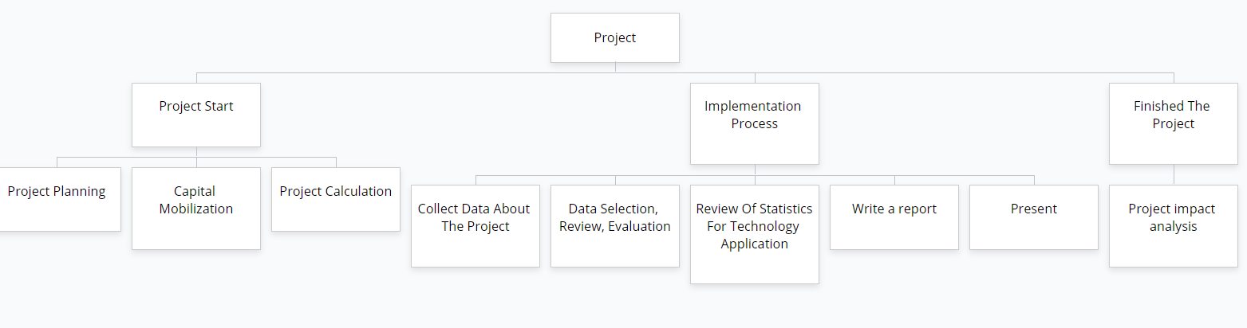

Figure 1: WBS

* **Task list**

**S**hows the basic tasks to be completed on the project through the task list

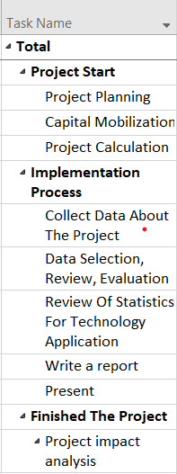

* **What is a Gantt Chart?**

One of the most prominent and valuable means of demonstrating activities (tasks or events) shown against time is a Gantt map, widely used in project management. A list of the operations is on the left of the map and a suitable time scale is at the end. Each activity is represented by a bar; the bar's position and length reflect the activity's start date, duration, and end date. (gantt.com, n.d.)

* **What are the key parts of a Gantt chart?**
* A Gantt chart is made up of several different elements. So let’s take a quick look at 8 key components so you know how to read a Gantt chart:
* Project list: To explain project work, runs vertically down the left of the Gantt map and can be organized into groups and subgroups
* Timeline: Stretches horizontally over the top of the Gantt map and displays months , weeks, days, and years
* Dateline: A vertical line that highlights the current date on the Gantt chart
* Bars: Horizontal markers on the right side of the Gantt map, reflecting assignments and indicating development, length, start and end dates.
* Milestones: Yellow diamonds that call out major events, dates, decisions, and deliverables
* Dependencies: Light gray lines linking activities in a certain order that need to take place
* 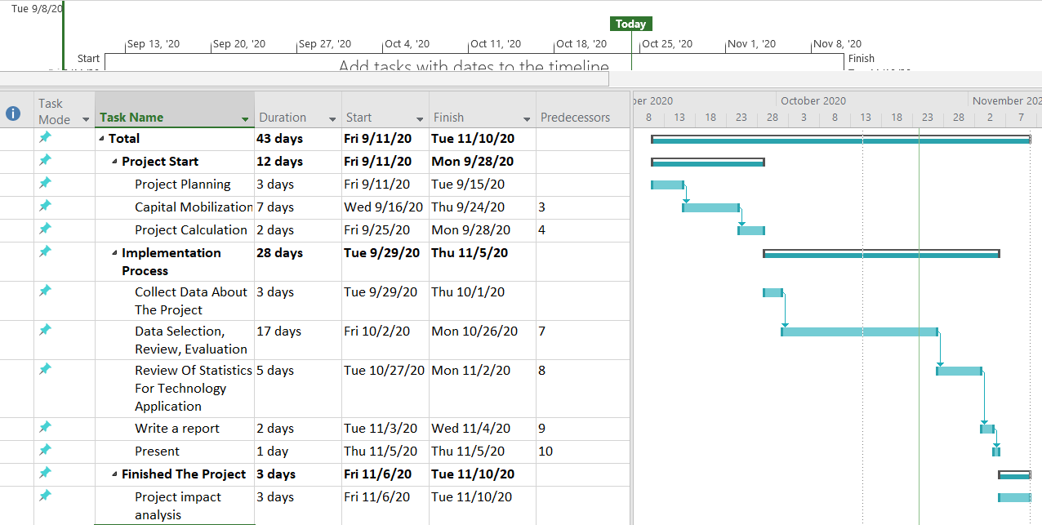Resource assigned: Indicates the person or team responsible for completing a task. (teamgantt.com, n.d.)

A list of activities on the left side of the map. The top of the chart has the right time period. Activities are represented by a bar that indicates the position and duration of the bar that mimics the start date, the time, and the end date of the operation. Here is the Gantt map using Microsoft Project 2019.

# **P4** Carry out small-scale research by applying qualitative and quantitative research methods appropriate for meeting project aims and objectives

* **Qualitative Research**

Qualitative analysis is most commonly used to achieve a deeper understanding of the basic concepts of the topic. Qualitative analysis relies on opinions and motives. Qualitative analysis is used to provide insight into the topic presented in the work or article. It can also help to generate concepts or theories at the outset of quantitative analysis. In this case, it is done in order to help focus the study itself. (wikipedia, n.d.)

* **Qualitative in the project:**
* Is this project more convenient than identifying parking lots for customers?
* Quality of the truth of the proposal?
* Does the implementation by sensors and cameras cost more than normal labor?
* Do customers really like it when using the service?
* Customer surveillance cameras and warning sensors affect the customer's driving experience?
* Will customers allow their data to be included in the system database?
* **Quantitative research**

Quantitative research is defined as a systematic investigation of phenomena by collecting quantifiable data and performing statistical, mathematical or computational techniques. Quantitative analysis gathers input from current and prospective consumers through sampling techniques and by submitting internet surveys, internet surveys, questionnaires, etc. The results of which can be seen in numerical form. (wikipedia, n.d.)

* There are many forms of primary quantitative analysis. They can be differentiated by the following four distinctive methods:
* Survey Research
* Correlational research
* Causal-comparative research
* Experimental research
* **Quantitative in the project**

|  |  |  |  |
| --- | --- | --- | --- |
| Question | High | Medium | Low |
| Fingerprint recognition speed quickly |  |  |  |
| The safety of the system |  |  |  |
| Accuracy |  |  |  |
| Identify multiple vehicles in and out |  |  |  |
| Ability to configure it |  |  |  |
| The level of customer satisfaction with the system |  |  |  |

# References

Anon., n.d. [Online]   
Available at: https://patthomson.net/2014/06/09/aims-and-objectives-whats-the-difference/#:~:text=(1)%20The%20aim%20is%20about,aim%20is%20therefore%20generally%20broad.  
[Accessed 12 10 2020].

Anon., n.d. [Online]   
Available at: https://keydifferences.com/difference-between-aim-and-objective.html#Definition  
[Accessed 12 10 2020].

Anon., n.d. [Online]   
Available at: https://patthomson.net/2014/06/09/aims-and-objectives-whats-the-difference/#:~:text=(1)%20The%20aim%20is%20about,aim%20is%20therefore%20generally%20broad.  
[Accessed 12 10 2020].

Anon., n.d. [Online]   
Available at: https://keydifferences.com/difference-between-aim-and-objective.html#Definition  
[Accessed 12 10 2020].

Anon., n.d. [Online]   
Available at: https://www.workbreakdownstructure.com/  
[Accessed 16 10 2020].

Anon., n.d. [Online]   
Available at: https://en.wikipedia.org/wiki/Work_breakdown_structure  
[Accessed 16 10 2020].

Anon., n.d. [Online]   
Available at: https://www.teamgantt.com/what-is-a-gantt-chart  
[Accessed 16 10 2020].

Anon., n.d. [Online]   
Available at: https://www.gantt.com/  
[Accessed 16 10 2020].

Anon., n.d. [Online]   
Available at: https://www.questionpro.com/blog/quantitative-research/  
[Accessed 16 10 2020].

Anon., n.d. [Online]   
Available at: https://blog.udemy.com/qualitative-vs-quantitative/?utm_source=adwords&utm_medium=udemyads&utm_campaign=DSA_Catchall_la.EN_cc.ROW&utm_content=deal4584&utm_term=_._ag_88010211481_._ad_437497337004_._kw__._de_c_._dm__._pl__._ti_dsa-40209827789_._li_9053233_  
[Accessed 16 10 2020].

gantt.com, n.d. [Online]   
Available at: https://www.gantt.com/  
[Accessed 25 10 2020].

teamgantt.com, n.d. [Online]   
Available at: https://www.teamgantt.com/what-is-a-gantt-chart  
[Accessed 25 10 2020].

wikipedia, n.d. [Online]   
Available at: https://en.wikipedia.org/wiki/Work_breakdown_structure  
[Accessed 25 10 2020].

wikipedia, n.d. [Online]   
Available at: https://en.wikipedia.org/wiki/Work_breakdown_structure  
[Accessed 25 10 2020].

wikipedia, n.d. [Online]   
Available at: https://en.wikipedia.org/wiki/Qualitative_research  
[Accessed 25 10 2020].

wikipedia, n.d. [Online]   
Available at: https://en.wikipedia.org/wiki/Quantitative_research  
[Accessed 25 10 2020].

wikipedia, n.d. [Online]   
Available at: https://en.wikipedia.org/wiki/Project_management  
[Accessed 25 10 2020].

www.gantt.com, n.d. [Online]   
Available at: https://www.gantt.com/  
[Accessed 24 10 2020].